**Lab 5: hosting a static website using Amazon s3**

Task1:hosting a static website using Amazon s3

* Create s3 bucket
* Unblock all public access
* Upload static website in that s3 bucket
* Write bucket policy

### Theory:

S3 Bucket: An S3 bucket is a container in Amazon S3 where files are stored. Each bucket has a unique name and is created in a specific region.

Static Website Hosting: Static website hosting in S3 allows you to host a website with fixed content (HTML, CSS, JavaScript, images) that does not change or require server-side processing.

Static Website: A static website is a site where the content is fixed and loads directly on the user's browser without needing server-side processing.

Dynamic Website: A dynamic website is a site where content changes based on user actions and requires server-side processing to display data.

### Steps:

1. Create S3 Bucket:

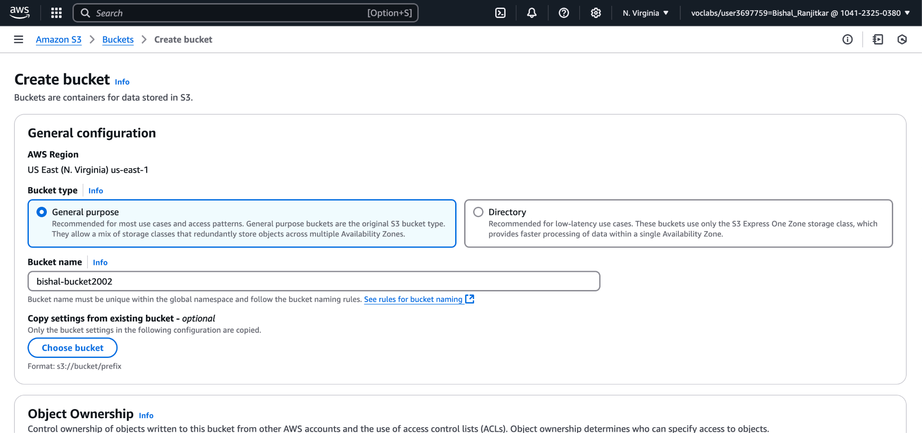

1. Unblock Public Access:

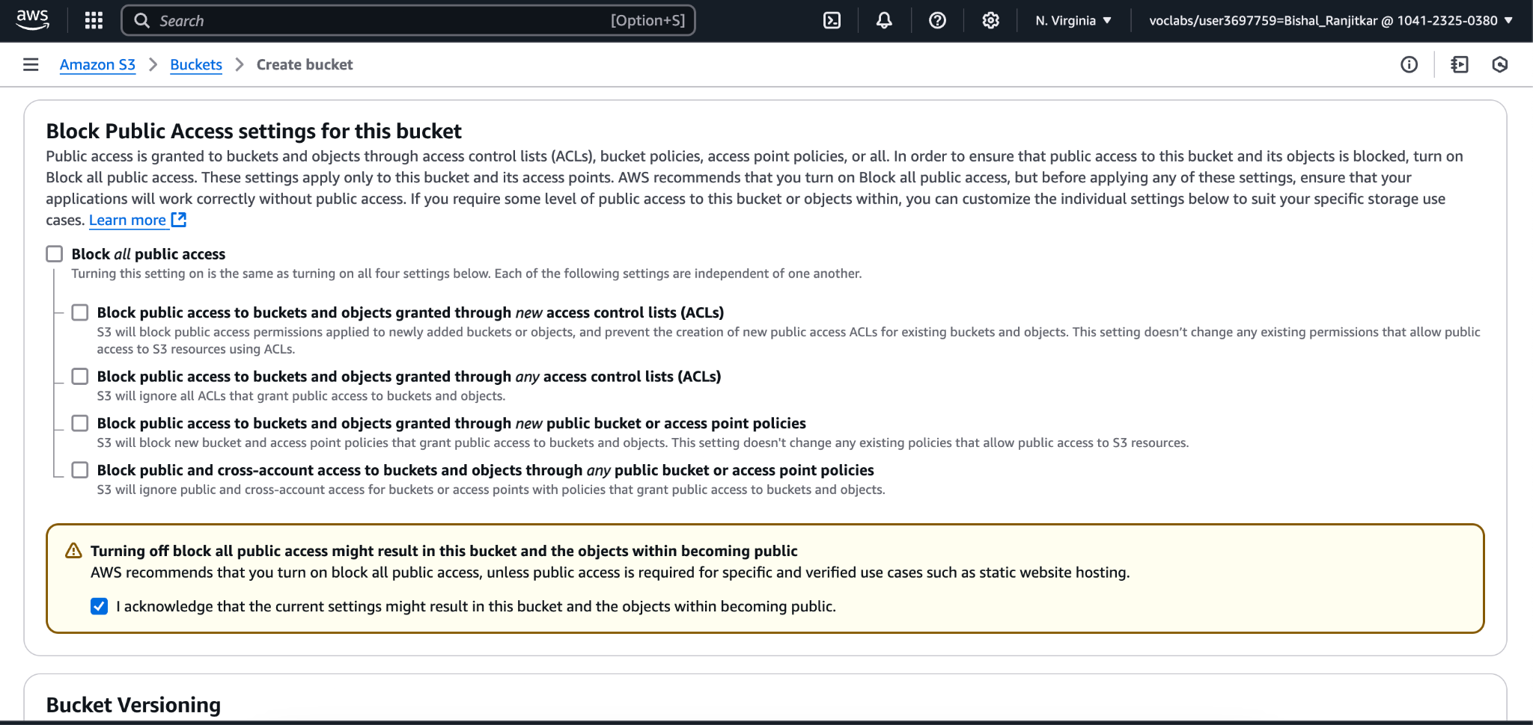

1. Upload Website Files:

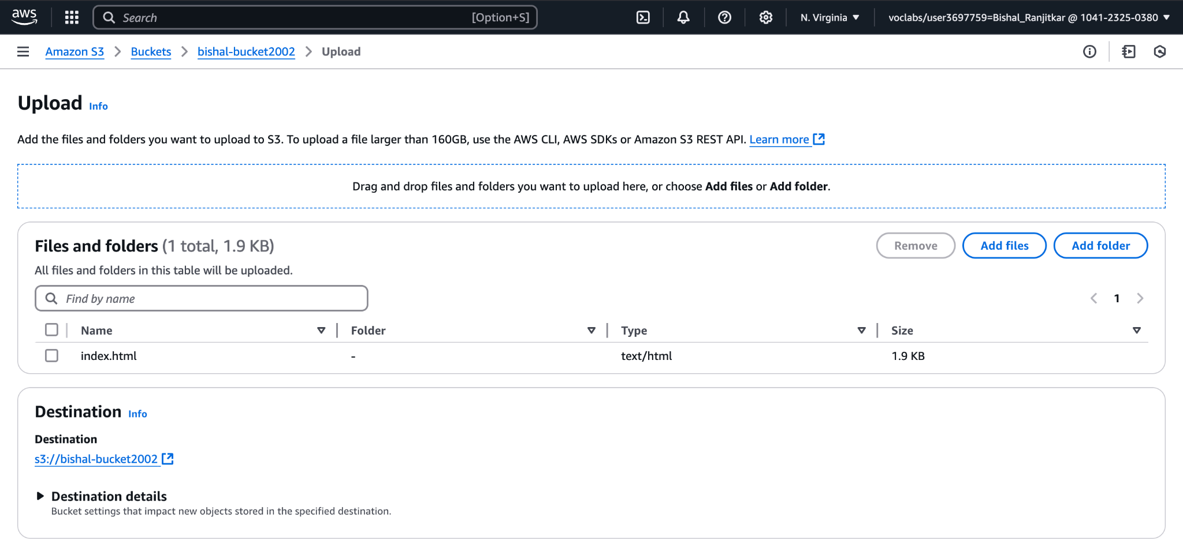

1. Enable Static Website Hosting:

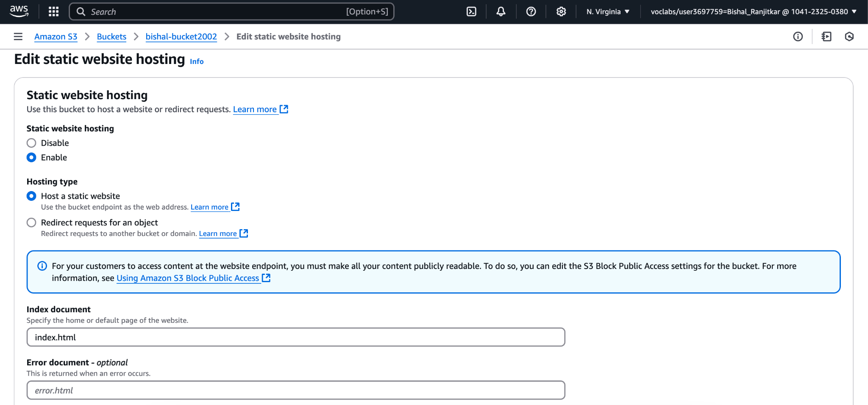

1. **Set Permissions (Bucket Policy)**:

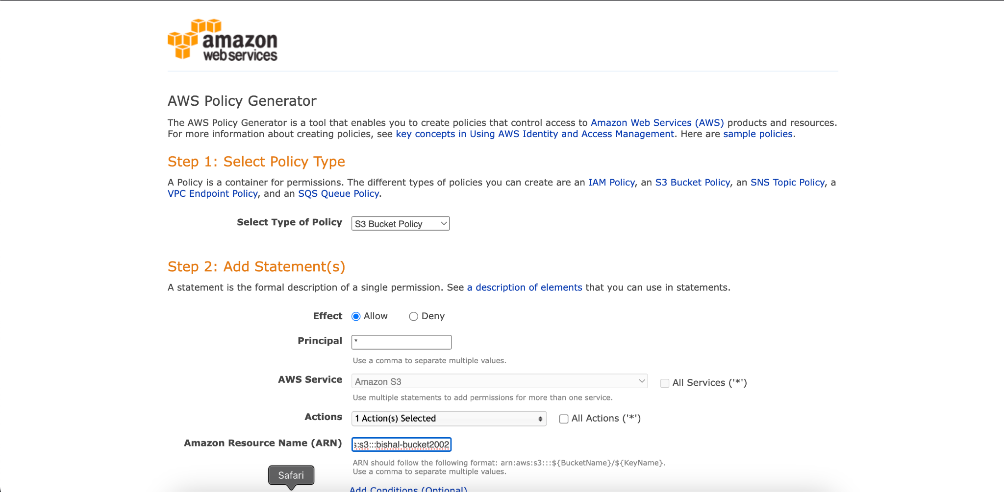

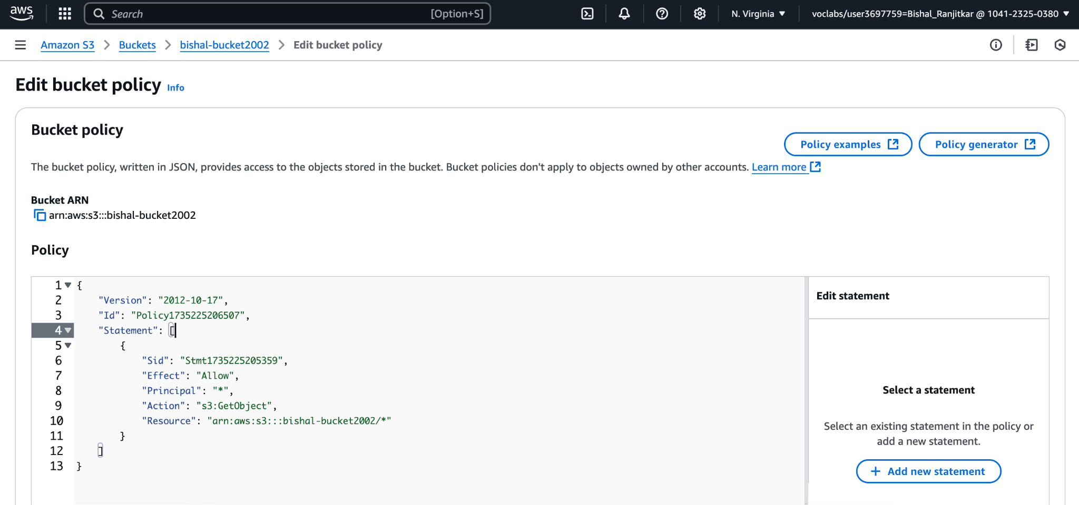

1. **Enable Static Website Hosting**:

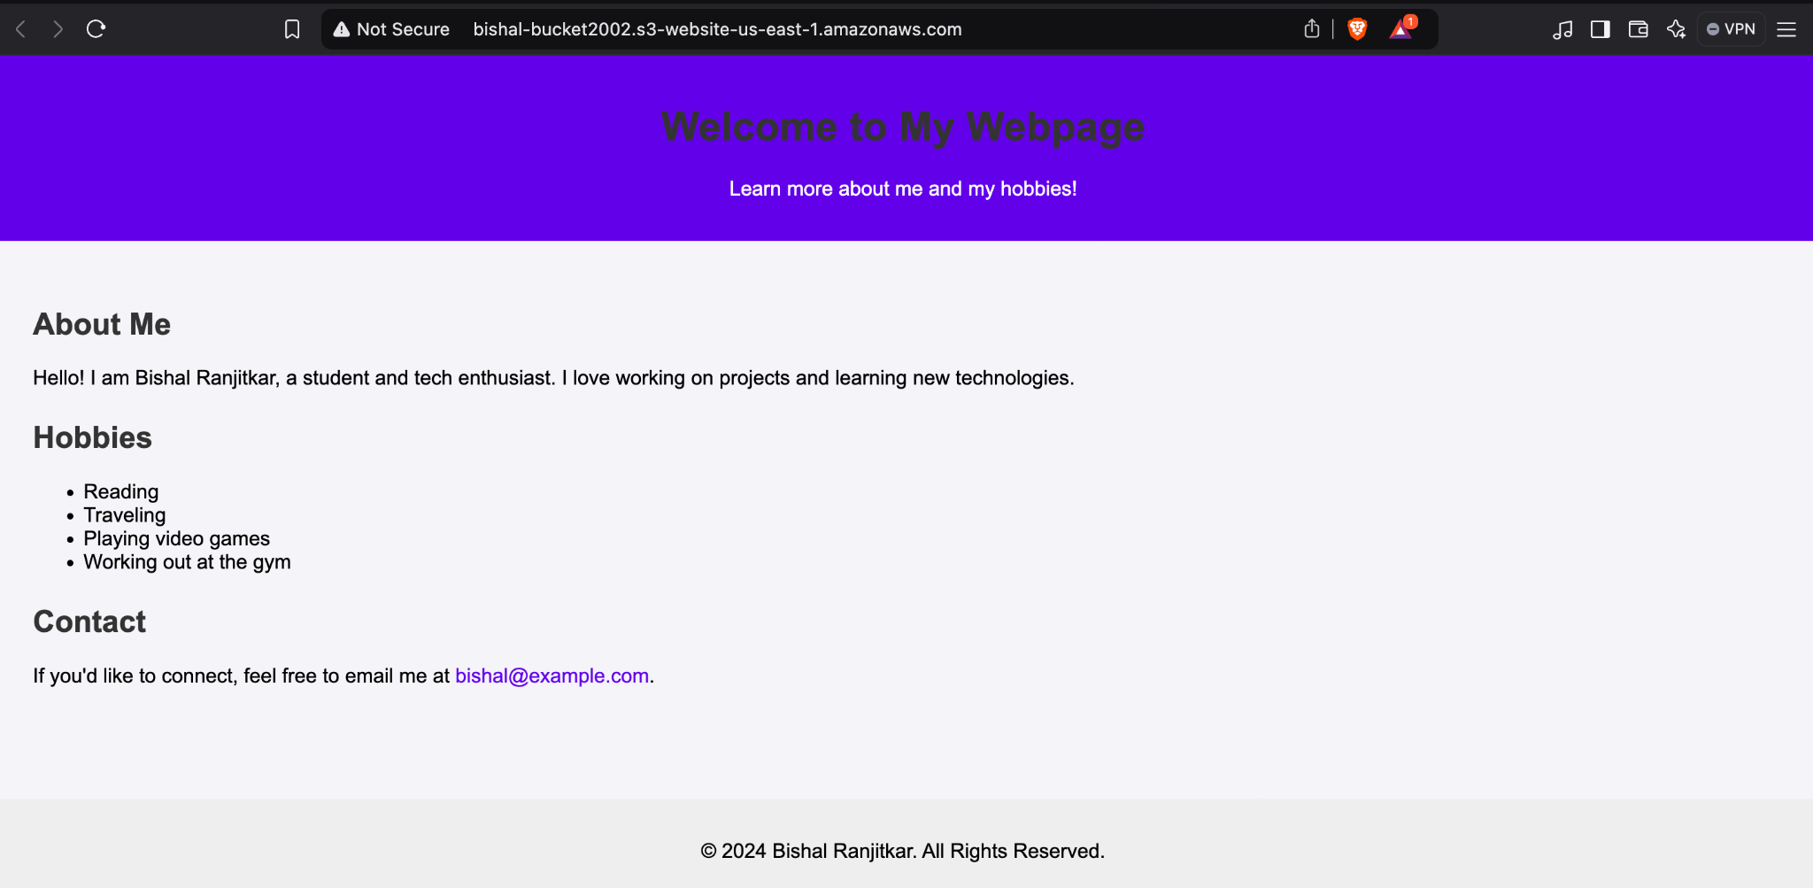

**Conclusion:**

In this setup, we created an S3 bucket for hosting a static website. The bucket was configured to allow public access and the necessary website files (HTML, CSS, images, etc.) were uploaded. We enabled static website hosting on the bucket, set up a bucket policy to allow public read access, and configured the necessary permissions. The static website is now accessible through a provided endpoint URL. This setup is simple, cost-effective, and ideal for hosting static websites securely on Amazon S3.